Passport SizeD Recent Photograph

International pharmacy summer School
Association of Pharmacy Student
Department of Pharmacy
Faculty of Medicine and Health Science
University of Muhammadiyah Yogyakarta
DIY - Indonesia
e: ipss@umy.ac.id
w: ipss.umy

STUDENT APPLICATION FORM IPSS 2017

PERSONAL DETAILS
Full Name :
Nick Name :
Sex : [ ] Male [ ] Female
Birthday :
Nationality :
Address :

Home Number :
Mobile Number :
Email Address :
Instant Messenger :
Preferred Method of Contact:
[ ] Phone [ ] Email
University :
School Attended : [ ] Pharmacy
Level: [ ] Student* [ ] Graduate
*Year Level in 2017 :

Native Language/s :
Other Language/s :
Passport Number :
Passport Exp Date :

ARRIVE AND DEPART INFORMATION
Arriving at Yogyakarta :
Departure from Yogyakarta :
I will use : BUS/ TRAIN/ PLAIN

EMERGENCY CONTACT DETAILS
Last Name :
First Name :
Contact Number :
Relationship :

MEDICAL INFORMATION
Date of last tetanus immunization:
Is there any other immunization you have taken? [ ] Yes – please specify [ ] No

Student Medicare :
Private Health Insurance :
Do you have any medical conditions? [ ] Yes [ ] No - If so, please provide details:

Do you have any allergies? [ ] Yes [ ] No - If so, please provide details

Will you be taking medication during Summer School? [ ] Yes – please specify [ ] No

Do you have any special dietary restrictions including for medical, religious or personal reasons? (e.g. vegetarian, halal food) [ ] Yes – please specify [ ] No

T-SHIRT DETAILS
Tshirt size: [ ] XS [ ] S [ ] M [ ] L [ ] XL [ ] XXL [ ] XXL

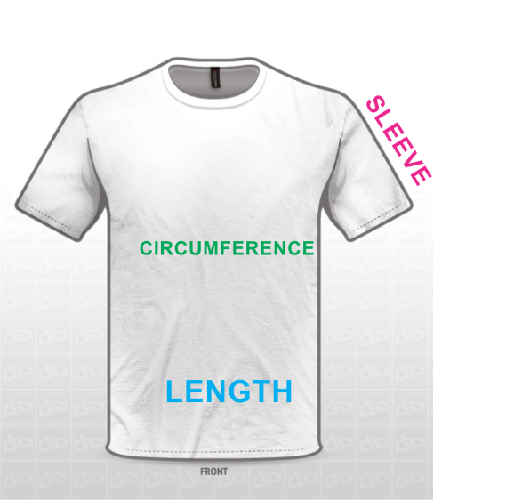
WAIST

SIZE | LENGTH | WAIST CIRCUMFERENCE | SLEEVE
S | 66 cm | 90 cm | 18 cm
M | 69 cm | 96 cm | 96 cm
L | 72 cm | 102 cm | 22 cm
XL | 75 cm | 108 cm | 24 cm
XXL | 77 cm | 118 cm | 25 cm
XXXL | 80 cm | 124 cm | 27 cm

LOCAL GSM NUMBER
Will you bring your mobile phone* to the program? [ ] Yes [ ] No
If so, would you like to use local GSM number while you are staying in Indonesia?
[ ] Yes [ ] No

We plan to provide a local GSM number to each of IPSS students. This program is intended to conduct an easier communication between students and the organizing committee members. We will also put in our consideration about the most competitive international call tariff before we choose which provider to use.

*Indonesia GSM networks range is available to use in only GSM900/1800 and 3G network. Please check your tri-band feature, while quad-band would not have any problem to run in any countries.

SUMMER SCHOOL EXPERIENCE
Is there any pharmacy summer school you have attended before? [ ] Yes – please specify [ ] No
Name | Topic | Year | City & Country

IPSS 2017 SURVEY
How do you rate your knowledge in the field of Indonesian indigenous medicine in modern medical treatment?
[ ] None, but I’m eager to know [ ] Beginner* [ ] Experienced in this field*
*If you check one of the boxes with this (*) sign, please state briefly why you rate yourself in that level.

How did you hear about IPSS 2017? (You can sign more than one checkbox)
[ ] Friend/previous IPSS student
[ ] Email
[ ] Mailing list, please specify
[ ] Faculty
[ ] Poster
[ ] Leaflet
[ ] Website (including Google search)
[ ] Publication in Medical Conference
[ ] Others, please specify

MOTIVATION AND EXPECTED OUTCOMES
Motivation letter:

In order to raise our students’ satisfaction, we will very please if you could state briefly your expected outcomes by joining IPSS 2016.

PAYMENT
- Cost
    - This payment includes: Tour and social programs activities to tourism objects, accommodation (home stay), transportation (arrival from airport to home stay, home stay to venue, any transportation needed during arranged educational and non educational programs, and departure from home stay to airport), two traditional program, and three times meal for the duration of the Summer School.
    - This payment does not include: Banking transfer, health insurance, visa and travel expenses.

- Additional accommodation: students will receive free accommodation during period of arrival on two days before the program starts, and departure until two days after the program ends. Please indicate to Liaison Officer if any extra nights of accommodation are required. (students will be charged an extra EUR 10 per night). Please note that additional accommodation covers accommodation only. Students are responsible for paying for their own food and transportation during the free/charged extra nights. Travel itinerary should be confirmed to the Liaison Officer one week before arrival or departure.

- Payments that have been made are not refundable.

- Before the IPSS 2016 starts, change/s to this “terms and conditions” are possible to be made by the Organizing Committee without any permission from the students.

Should any change/s have to be made, the Liaison Officer will inform all students immediately.

METHOD OF PAYMENT
Bank Transfer
We will start the payment period on :
- Early : 25th February 2017- 30th April 2017
- Middle : 1st May 2017 – 31st May 2017
- Late : 1st June 2017 – 30th June 2017

The official bank account will be announced soon to the applicants via email.
If you have any problem with this method of payment, feel free to contact us.

Date:
Signature:

Please print this form after you fill in its entirety, and sign it with written signature.
Send a color scanned document of this form to : ipss@umy.ac.id , and bring the original form when you join this program.

